Blue Water Developmental Housing, Inc.

Quality Improvement Goals

2016-2017
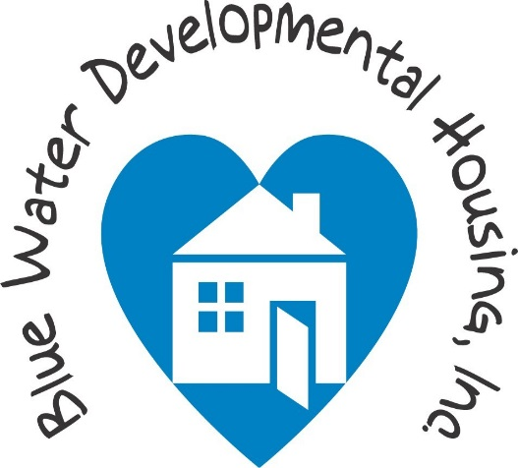

Goal 1
To increase awareness of workplace safety
Objective
- Identify total number of work injuries resulting in medical care only for fiscal year 2015-2016 and decrease this total by 25% for fiscal year 2016-2017.
- Identify total cost of worker’s compensation for fiscal year 2015-2016 and decrease this total by 25% for fiscal year 2016-2017
Strategies
- Offer health and safety training to 100% of employees on slips, trips, and falls.
- Offer health and safety training to 100% of employees on proper lifting techniques
Assigned Responsibility
- Program supervisors

Goal 2
To increase employment retention rate
Objective
- To identify reasons for employment turnover
- To reduce the fiscal year 15-16 turnover rate of 27% to 17% for fiscal year 16-17
Strategies
- Conduct an organization wide employee satisfaction survey
- Educate management team on employment retention strategies
- Assess the feasibility of increasing the wage scale
Assigned Responsibility
- Division directors and the human resources and quality assurance specialist

Goal 3
100% of employees will receive ongoing training to insure competence
Objective
- All employees of BWDH will receive a minimum of 25 hours of Professional Development training annually.
- All employees of BWDH will receive at least twelve hours of training related specifically tailored to the needs of the individuals supported in their particular home setting as part of their 25 hours of Professional Development training.
Strategies
- Secure or provide a minimum of 25 hours of training for each individual employee for overall professional development.
- Secure or provide a minimum of 12 hours of training for each individual employee for overall professional development.
Assigned Responsibility
- Program supervisors

Goal 1
To increase awareness of workplace safety.
Objective 1
Identify total number of work injuries resulting in medical care only for fiscal year 2015-2016 and decrease this total by 25% for fiscal year 2016-2017.

 | Residential | Community Based  (Integration/Supports) | Community Based  (Children’s Waiver)
1st Quarter  October-December | 1 | 2 | 0
2nd Quarter  January-March | 2 | 0 | 0
3rd Quarter
April-June
4th Quarter
July-September
Total

Objective 2
Identify total cost of worker’s compensation for fiscal year 2015-2016 and decrease this total by 25% for fiscal year 2016-2017

 | Residential | Community Based  (Integration/Supports) | Community Based  (Children’s Waiver)
1st Quarter  October-December | 0 | $997.96 | 0
2nd Quarter  January-March | $992.56 | 0 | 0
3rd Quarter
April-June
4th Quarter
July-September
Total

Strategy 1
Offer Health and Safety Training to 100% of employees on slips, trips, and falls.

 | Residential | Community Based  (Integration/Supports) | Community Based  (Children’s Waiver)
1st Quarter  October-December | 83%  (15 of 18) | 100%  54 of 54 | N/A
2nd Quarter  January-March | 65%  (26 of 40) | 100%  23 of 23 | N/A
3rd Quarter
April-June
4th Quarter
July-September
Total | As of 5/8/17  92%  (58 of 63)  *including employees who were past due
Strategy 2
Offer Health and Safety Training to 100% of employees on proper lifting techniques

 | Residential | Community Based  (Integration/Supports) | Community Based  (Children’s Waiver)
1st Quarter  October-December | 93%  (14 of 15) | 100%  49 of 49 | N/A
2nd Quarter  January-March | 83%  (33 of 40) | 100%  23 of 23 | N/A
3rd Quarter
April-June
4th Quarter
July-September
Total | As of 5/8/17  93%  (56 of 60)  *including employees who were past due

Goal 2
To increase employment retention rate.
Objective 1
To identify reasons for employment turnover
1st Quarter
October-December
2nd Quarter  January-March | January 10 – Administrative meeting – agenda items: Retention and Recognition  January 13 – Formalize plan to address Retention and Recognition with supervisors.  January 26 – Webinar with management team – regarding retention  February 7 – Officially review plan with management team and start action plan for addressing reasons for employment turnover.  Strengthen the exit interview process to identify reasons why employees are leaving the organization.
3rd Quarter
April-June
4th Quarter
July-September
Objective 2
To reduce the fiscal year 15-16 turnover rate of 27% to 17% for fiscal year 16-17
Strategy 1
Conduct an organization wide employee satisfaction survey
1st Quarter
October-December
2nd Quarter  January-March | Survey created in February, conducted in March
3rd Quarter  April-June | Employee satisfaction results reviewed in April
4th Quarter
July-September

Strategy 2
Educate management team on employment retention strategies
1st Quarter
October-December
2nd Quarter  January-March | January 26 – management team participated in a webinar “Doing More with Less: How to Motivate and Reward your Overworked Staff During Lean Times”
3rd Quarter
April-June
4th Quarter
July-September
Strategy 3
Assess the feasibility of increasing the wage scale.
1st Quarter
October-December
2nd Quarter  January-March | Tactical approach  - Review all full time equivalents for each program
3rd Quarter
April-June
4th Quarter
July-September

Goal 3
100% of employees will receive annual training to insure competence.

Objective 1
All employees of BWDH will receive a minimum of 25 hours of Professional Development training annually.
Objective 2
All employees of BWDH will receive at least twelve hours of training related specifically tailored to the needs of the individuals supported in their particular home setting as part of their 25 hours of Professional Development training.
Strategy 1
Secure or provide a minimum of 25 hours of training for each individual employee for overall professional development.
 | Residential | Community Based  (Integration/Supports) | Community Based  (Children’s Waiver)
1st Quarter  October-December | 77% (6.25 hours)  84 of 109 employees | 73% (6.25 hours)  137 of 187 employees | 25% (6.25 hours)  1 of 4 employees
2nd Quarter  January-March | 75% (12.5 hours)  82 of 109 employees | 52% (12.5 hours)  97 of 187 employees | 25% (12.5 hours)  1 of 4 employees
3rd Quarter
April-June
4th Quarter
July-September
Total
Strategy 2
Secure or provide a minimum of 12 hours of training for each individual employee for overall professional development.

 | Residential | Community Based  (Integration/Supports) | Community Based  (Children’s Waiver)
1st Quarter  October-December | 97% (3 hours)  106 of 109 employees | 93% (3 hours)  174 of 187 employees | 75% (3 hours)  3 of 4 employees
2nd Quarter  January-March | 87% ( 6 hours)  95 of 109 employees | 73%( 6 hours)  137 of 187 employees | 50% ( 6 hours)  2 of 4 employees
3rd Quarter
April-June
4th Quarter
July-September
Total

